Order of Service in Church

ALL STAND as the funeral procession enters the church. Once the family are seated, please SIT

The Priest reads one or more scriptural sentences.

The Gathering

Priest: We meet in the name of Jesus Christ, who died and was raised to the glory of God the Father. Grace and mercy be with you.
All: Amen.

The priest introduces the service

Hymn: All my hope on God is founded;
(stand) he doth still my trust renew.
Me through change and chance he guideth,
only good and only true.
God unknown, he alone -
calls my heart to be his own.

Pride of man and earthly glory,
sword and crown betray his trust;
what with care and toil he buildeth,
tower and temple, fall to dust.
But God’s power, hour by hour,
is my temple and my tower.

God’s great goodness aye endureth,
deep his wisdom, passing thought:
splendour, light and life attend him,
beauty springeth out of naught,
Evermore from his store
new-born worlds rise and adore.

Daily doth th’ Almighty giver
bounteous gifts on us bestow;
his desire our soul delighteth,
pleasure leads us where we go.
Love doth stand at his hand;
joy doth wait on his command.

Still from man to God eternal
sacrifice of praise be done,
high above all praises praising
for the gift of Christ his Son.
Christ doth call one and all:
ye who follow shall not fall.

Priest: Sitting or kneeling, let us pray:

As children of a loving heavenly Father, let us ask his forgiveness,
for he is gentle and full of compassion.

All: God of mercy,
we acknowledge that we are all sinners.
We turn from the wrong
that we have thought and said and done,
and are mindful of all that we have failed to do.
For the sake of Jesus, who died for us,
forgive us for all that is past,
and help us to live each day
in the light of Christ our Lord. Amen.

Priest: May God our Father forgive us our sins
and bring us to the eternal joy of his kingdom,
where dust and ashes have no dominion.
All Amen.

Priest: Let us pray

Eternal God, our maker and redeemer,
grant us with Irene and all the faithful departed
the sure benefits of your Son's saving passion
and glorious resurrection:
that, in the last day,
when you gather up all things in Christ,
we may with them enjoy the fullness of your promises;
through Jesus Christ your Son our Lord,
who is alive and reigns with you,
in the unity of the Holy Spirit,
one God, now and for ever.
All: Amen.

The Ministry of the Word

A reading from the First Letter of St Peter

Praise be to the God and Father of our Lord Jesus Christ! In his great mercy he has given us new birth into a living hope through the resurrection of Jesus Christ from the dead, and into an inheritance that can never perish, spoil or fade – kept in heaven for you, who through faith are shielded by God's power until the coming of the salvation that is ready to be revealed in the last time. In this you greatly rejoice, though now for a little while you may have had to suffer grief in all kinds of trials. These have come so that your faith – of greater worth than gold, which perishes even though refined by fire – may be proved genuine and may result in praise, glory and honor when Jesus Christ is revealed. Though you have not seen him, you love him; and even though you do not see him now, you believe in him and are filled with an inexpressible and glorious joy, for you are receiving the goal of your faith, the salvation of your souls.

This is the word of the Lord.
All: Thanks be to God.

Gradual hymn: (please stand)

Make me a channel of your peace.
Where there is hatred let me bring your love.
where there is injury, your pardon, Lord,
and where there's doubt, true faith in you.

Oh Master, grant that I may never seek
so much to be consoled as to console,
to be understood, as to understand,
to be loved, as to love with all my soul.
Make me a channel of your peace.
Where there's despair in life, let me bring hope.
Where there is darkness, only light,
and where there's sadness, ever joy.

Oh Master, grant that I may never seek
so much to be consoled as to console,
to be understood, as to understand,
to be loved, as to love with all my soul.

Make me a channel of your peace.
It is in pardoning that we are pardoned,
in giving of ourselves that we receive,
and in dying that we're born to eternal life.

THE GOSPEL (please remain standing)

Hear the Gospel of our Lord Jesus Christ according to St. John [Jn 6. 35-40]
All: Glory to you, O Lord

Then Jesus declared, "I am the bread of life. Those who come to me will never go hungry, and those who believe in me will never be thirsty. But as I told you, you have seen me and still you do not believe. All that the Father gives me will come to me, and whoever comes to me I will never drive away. For I have come down from heaven not to do my will but to do the will of him who sent me. And this is the will of him who sent me, that I shall lose none of all that he has given me, but raise them up at the last day. For my Father's will is that everyone who looks to the Son and believes in him shall have eternal life, and I will raise them up at the last day."

This is the Gospel of the Lord
All: Praise to you, O Christ

Please be seated
The Address.

The Prayers:

Priest: God of mercy, Lord of life, you have made us in your image to reflect your truth and light: we give you thanks for Irene, for the grace and mercy she received from you, for all that was good in her life, for the memories we treasure today.

(after a short period of silence)

Priest: Lord, in your mercy
All: hear our prayer.

Priest: You promised eternal life to those who believe. Remember for good this your servant Irene, and all who have died and come to mind at this time. Bring all who rest in Christ into the fullness of your kingdom where sins have been forgiven and death is no more.

(after a short period of silence)

Priest: Lord, in your mercy
All: hear our prayer.

Priest: Your mighty power brings joy out of grief and life out of death. Look in mercy on Harry, on all Irene’s family and all who mourn at this time. Give them patient faith in times of darkness. Strengthen them with the knowledge of your love.

(after a short period of silence)

Priest: Lord, in your mercy
All: hear our prayer.

Priest: Father, you are tender towards your children and your mercy is over all your works. Heal the memories of hurt and failure. Give us the wisdom and grace to use aright the time that is left to us here on earth, to turn to Christ and follow in his steps in the way that leads to everlasting life.

(after a short period of silence)

Priest: Lord, in your mercy
All: hear our prayer.
All: God of mercy, entrusting into your hands all that you have made and rejoicing in our communion with all your faithful people, we make our prayers through Jesus Christ our Saviour. Amen.

THE LITURGY OF THE SACRAMENT

The Peace (Please stand)

Priest: Jesus says: Peace I leave with you; my peace I give to you.
Not as the world gives do I give you.
Do not let your hearts be troubled, neither let them be afraid.

Priest: The peace of the Lord be always with you
All: And also with you

Priest: Let us offer one another a sign of peace.

Everyone is invited to share the peace with one another.

Offertory Hymn:

Lord of all hopefulness, Lord of all joy,
whose trust, ever childlike, no cares could destroy,
be there at our waking, and give us, we pray,
your bliss in our hearts, Lord, at the break of the day.

Lord of all eagerness, Lord of all faith,
whose strong hands were skilled at the plane and the lathe,
be there at our labours, and give us, we pray,
your strength in our hearts, Lord, at the noon of the day.

Lord of all kindliness, Lord of all grace,
your hands swift to welcome, your arms to embrace,
be there at our homing, and give us, we pray,
your love in our hearts, Lord, at the eve of the day.

Lord of all gentleness, Lord of all calm,
whose voice is contentment, whose presence is balm,
be there at our sleeping, and give us, we pray,
your peace in our hearts, Lord, at the end of the day.

Eucharistic Prayer A (please kneel)

Priest: The Lord is here.
All: His Spirit is with us.

Priest: Lift up your hearts.
All: We lift them to the Lord.

Priest: Let us give thanks to the Lord our God.
All: It is right to give thanks and praise.

Priest: It is indeed right, it is our duty and our joy, at all times and in all places to give you thanks and praise, holy Father, heavenly King, almighty and eternal God, through Jesus Christ your Son our Lord.

And now we give you thanks because through him you have given us the hope of a glorious resurrection; so that, although death comes to us all, yet we rejoice in the promise of eternal life; for to your faithful people life is changed, not taken away; and when our mortal flesh is laid aside an everlasting dwelling place is made ready for us in heaven.

Therefore with angels and archangels, and with all the company of heaven, we proclaim your great and glorious name, for ever praising you and saying:
All: Holy, holy, holy Lord, God of power and might, heaven and earth are full of your glory. Hosanna in the highest. Blessed is he who comes in the name of the Lord. Hosanna in the highest.

Priest: Accept our praises, heavenly Father, through your Son our Saviour Jesus Christ, and as we follow his example and obey his command, grant that by the power of your Holy Spirit these gifts of bread and wine may be to us his body and his blood;

who, in the same night that he was betrayed, took bread and gave you thanks; he broke it and gave it to his disciples, saying: Take, eat; this is my body which is given for you; do this in remembrance of me.

In the same way, after supper he took the cup and gave you thanks; he gave it to them, saying: Drink this, all of you; this is my blood of the new covenant, which is shed for you and for many for the forgiveness of sins. Do this, as often as you drink it, in remembrance of me.

Therefore, heavenly Father, we remember his offering of himself made once for all upon the cross; we proclaim his mighty resurrection and glorious ascension; we look for the coming of your kingdom, and with this bread and this cup we make the memorial of Christ your Son our Lord.

Priest: Great is the mystery of faith:
All: Christ has died: Christ is risen: Christ will come again.

Priest Accept through him, our great high priest, this our sacrifice of thanks and praise, and as we eat and drink these holy gifts in the presence of your divine majesty, renew us by your Spirit, inspire us with your love and unite us in the body of your Son, Jesus Christ our Lord.

Through him, and with him, and in him, in the unity of the Holy Spirit, with all who stand before you in earth and heaven, we worship you, Father almighty, in songs of everlasting praise:
All: Blessing and honour and glory and power
be yours for ever and ever. Amen.

Priest: Let us pray with confidence as our Saviour taught us
All: Our Father, who art in heaven, hallowed be thy name; thy kingdom come; thy will be done; on earth as it is in heaven. Give us this day our daily bread. And forgive us our trespasses, as we forgive those who trespass against us. And lead us not into temptation; but deliver us from evil. For thine is the kingdom, the power and the glory, for ever and ever. Amen.

Priest: We break this bread to share in the Body of Christ.
All: Though we are many, we are one body,
because we all share in one bread.

Priest: Jesus is the Lamb of God who takes away the sin of the world.
Blessed are those who are called to his supper.
All: Lord, I am not worthy to receive you,
but only say the word, and I shall be healed.

Holy Communion is administered at the front of Church. Everyone is warmly invited to receive Holy Communion at this Eucharist. Those who prefer to receive a blessing are also invited to come forward at the same time.
During the distribution of the sacrament:

1 | I, the Lord of sea and sky,  I have heard my people cry.  All who dwell in dark and sin  my hand will save.  I who made the stars of night,  I will make their darkness bright.  Who will bear my light to them?  Whom shall I send? | 2 | I the Lord of snow and rain,  I have borne my people’s pain.  I have wept for love of them.  They turn away.  I will break their hearts of stone,  give them hearts for love alone.  I will speak my word to them.  Whom shall I send?
 | Here I am, Lord. Is it I Lord?  I have heard you calling in the night.  I will go Lord, if you lead me.  I will hold your people in my heart. | 3 | I, the Lord of wind and flame,  I will tend the poor and lame.  I will set a feast for them.  My hand will save.  Finest bread I will provide  till their hearts are satisfied.  I will give my life to them.  Whom shall I send?

Commendation and farewell [please stand]

Priest: Let us commend Irene to the mercy of God our Maker and Redeemer.

The coffin is sprinkled with water taken from the baptismal font

Priest: With this water we call to mind Irene’s baptism. As Christ went through the deep waters of death for us, so may he bring us to the fullness of resurrection life with Irene and all the redeemed.

God our creator and redeemer, by your power Christ conquered death and entered into glory. Confident of his victory and claiming his promises, we entrust Irene to your mercy in the name of Jesus our Lord, who died and is alive and reigns with you, now and for ever. Amen

All: Heavenly Father,
in your Son Jesus Christ
you have given us a true faith and a sure hope.
Strengthen this faith and hope in us all our days,
that we may live as those who believe in
the communion of saints,
the forgiveness of sins
and the resurrection to eternal life;
through Jesus Christ our Lord. Amen.

May God, in his infinite love and mercy, bring the whole Church, living and departed in the Lord Jesus, to a joyful resurrection, and the fulfilment of his eternal kingdom. Amen.

Hymn: Forth in thy name, O Lord, I go,
(stand) My daily labour to pursue;
Thee, only thee, resolved to know,
In all I think, or speak, or do.

The task thy wisdom hath assigned
O let me cheerfully fulfil;
In all my works thy presence find,
And prove thy good and perfect will

Thee may I set at my right hand,
Whose eyes my inmost substance see,
And labour on at thy command,
And offer all my works to thee.

Give me to bear thy easy yoke,
And every moment watch and pray,
And still to things eternal look,
And hasten to thy glorious day;

For thee delightfully employ
Whate’er thy bounteous grace hath given,
And run my course with even joy,
And closely walk with thee to heaven.

Acknowledgement: Common Worship: Pastoral Services, material from which is included in this service, is copyright © The Archbishops’ Council (2000)

The Parish Church of St Andrew

Orford with Longford, Warrington

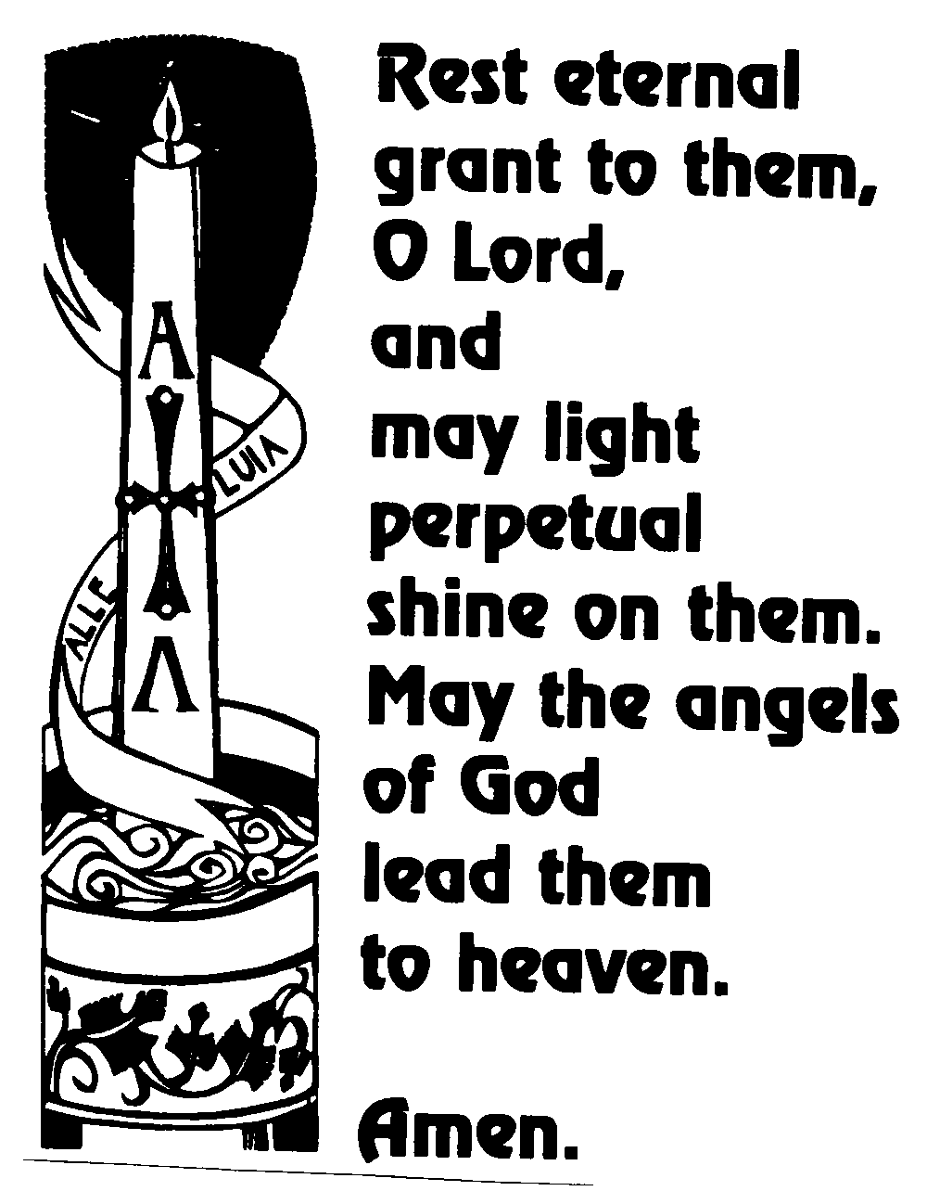

IRENE ROWAN

18th September 2003

I am sure that neither death nor life, nor angels, nor principalities nor powers, nor things present, nor things to come, nor height, nor depth, nor anything else in all creation can separate us from the love of God in Christ Jesus our Lord.

